**Practical 1: Using power apps design using blank canvas**

Step 1: Open Microsoft Power Apps and Sign in using the enterprise account credentials

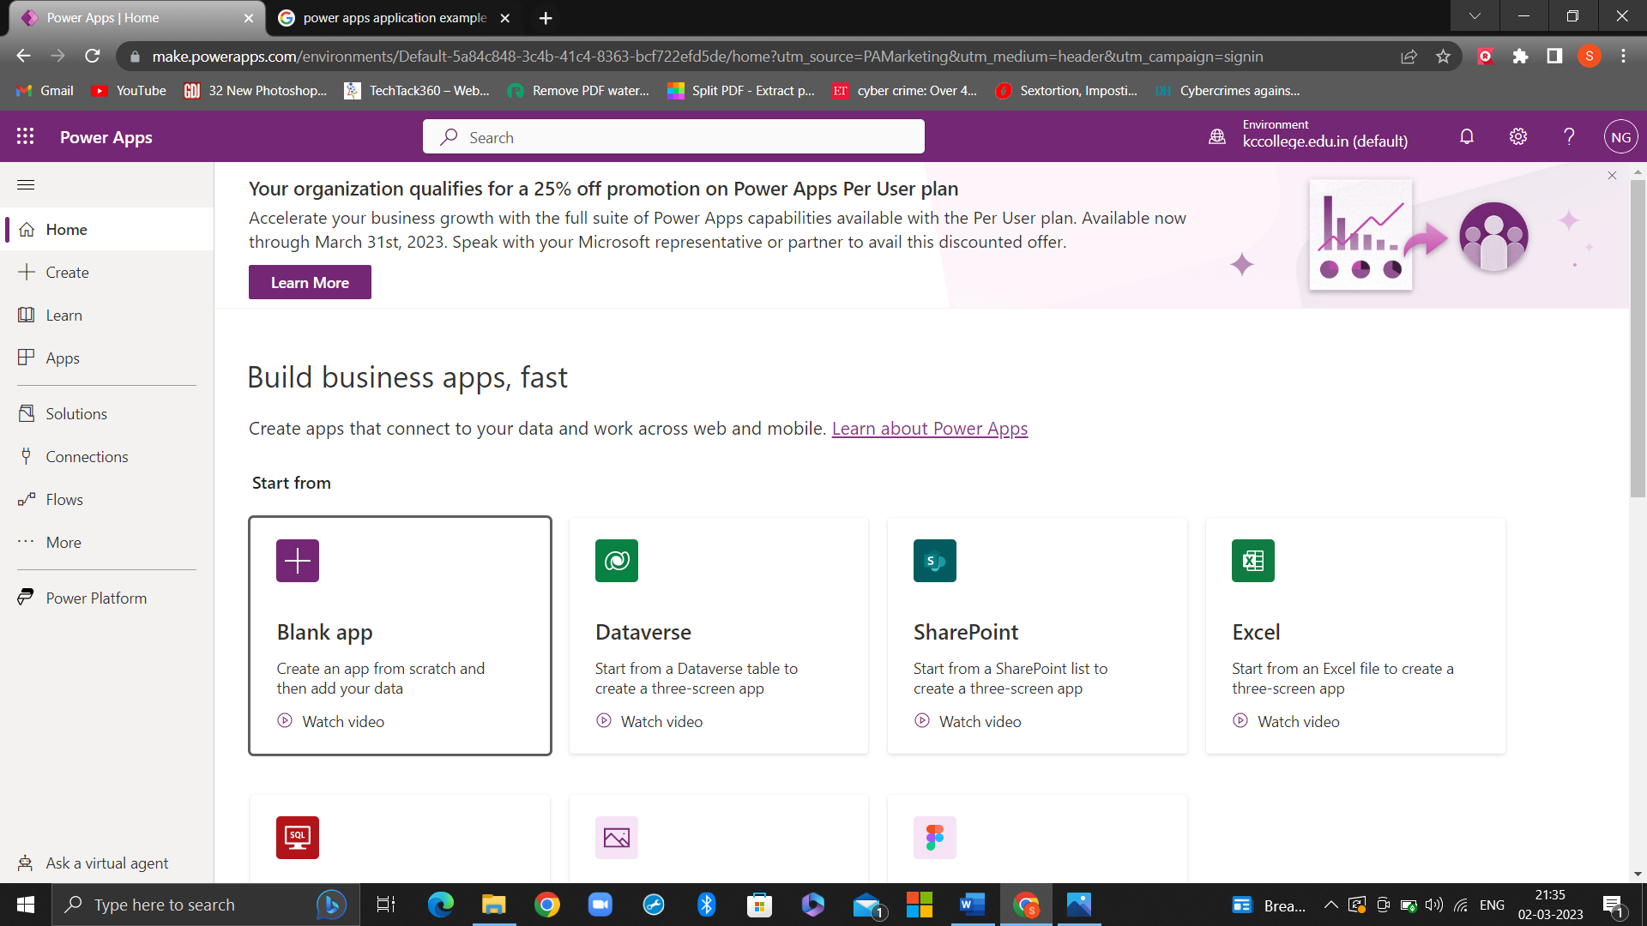

Step 2: Click on Blank app > Blank Canvas App > Create. Give the name to the app

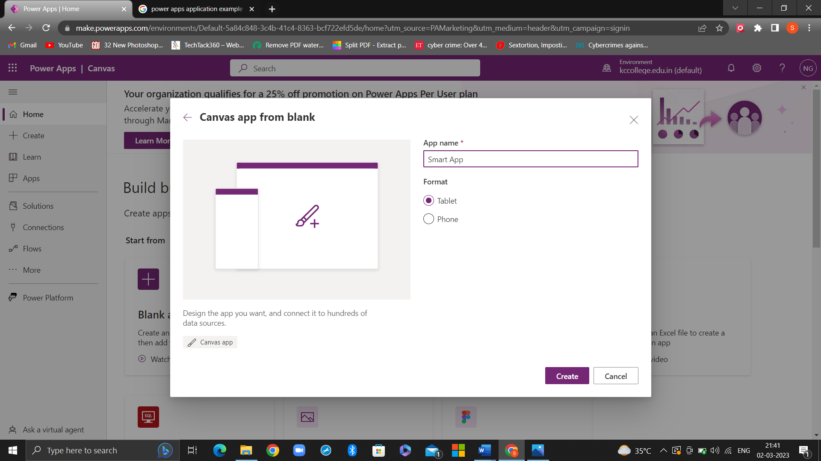

Step 3: When you click on create, you will see a new screen with multiple options. Click on Insert > Text Label, Text Input, Button etc.

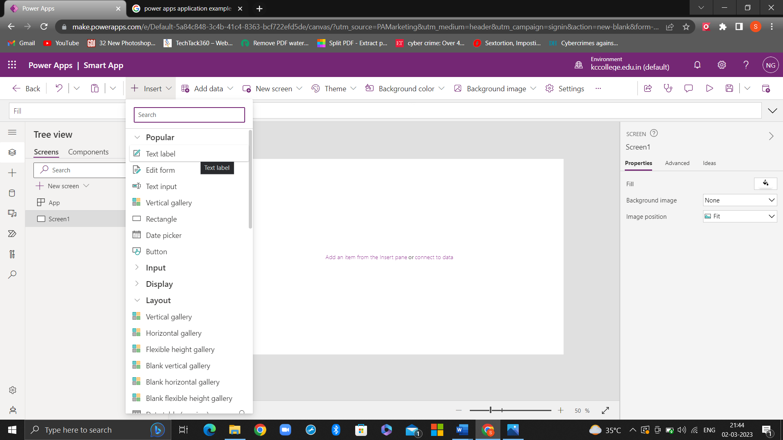

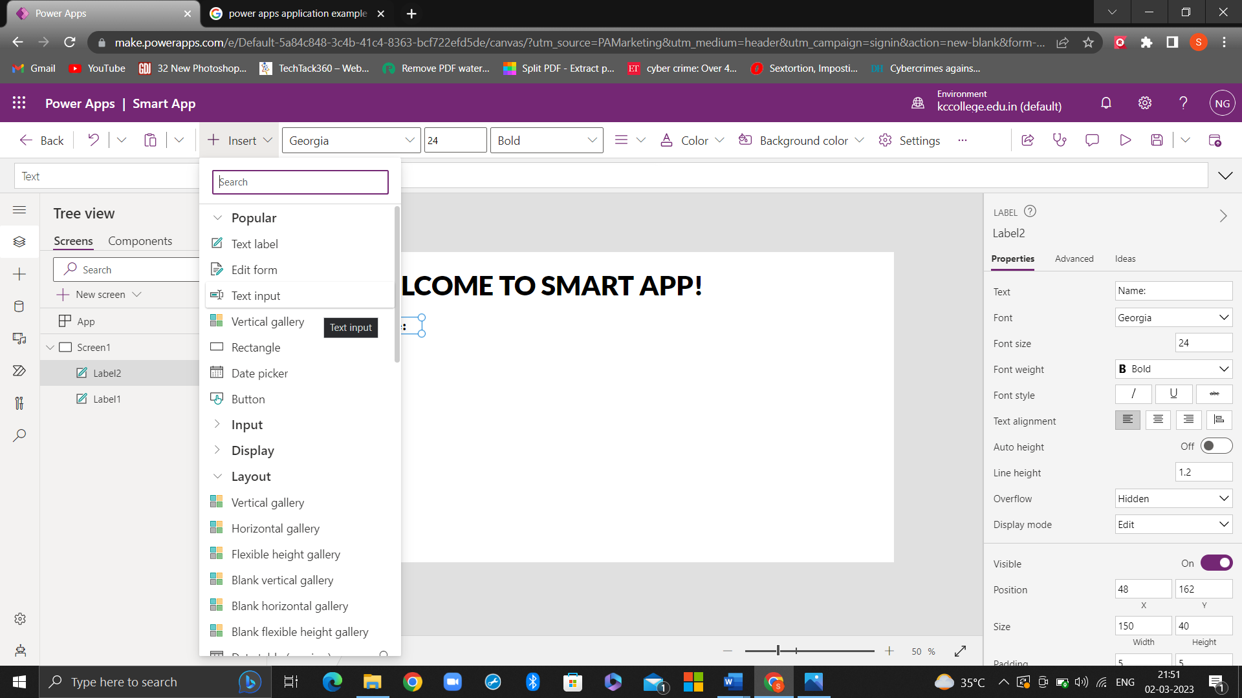

Step 4: When the final app is ready click on the play button on the top right corner to fill the details.

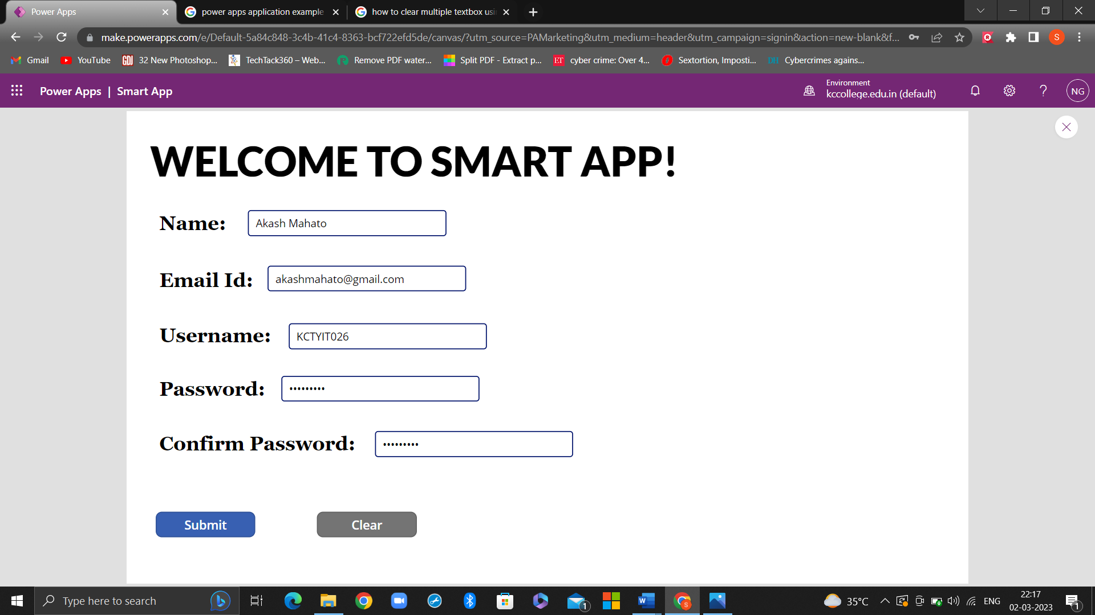

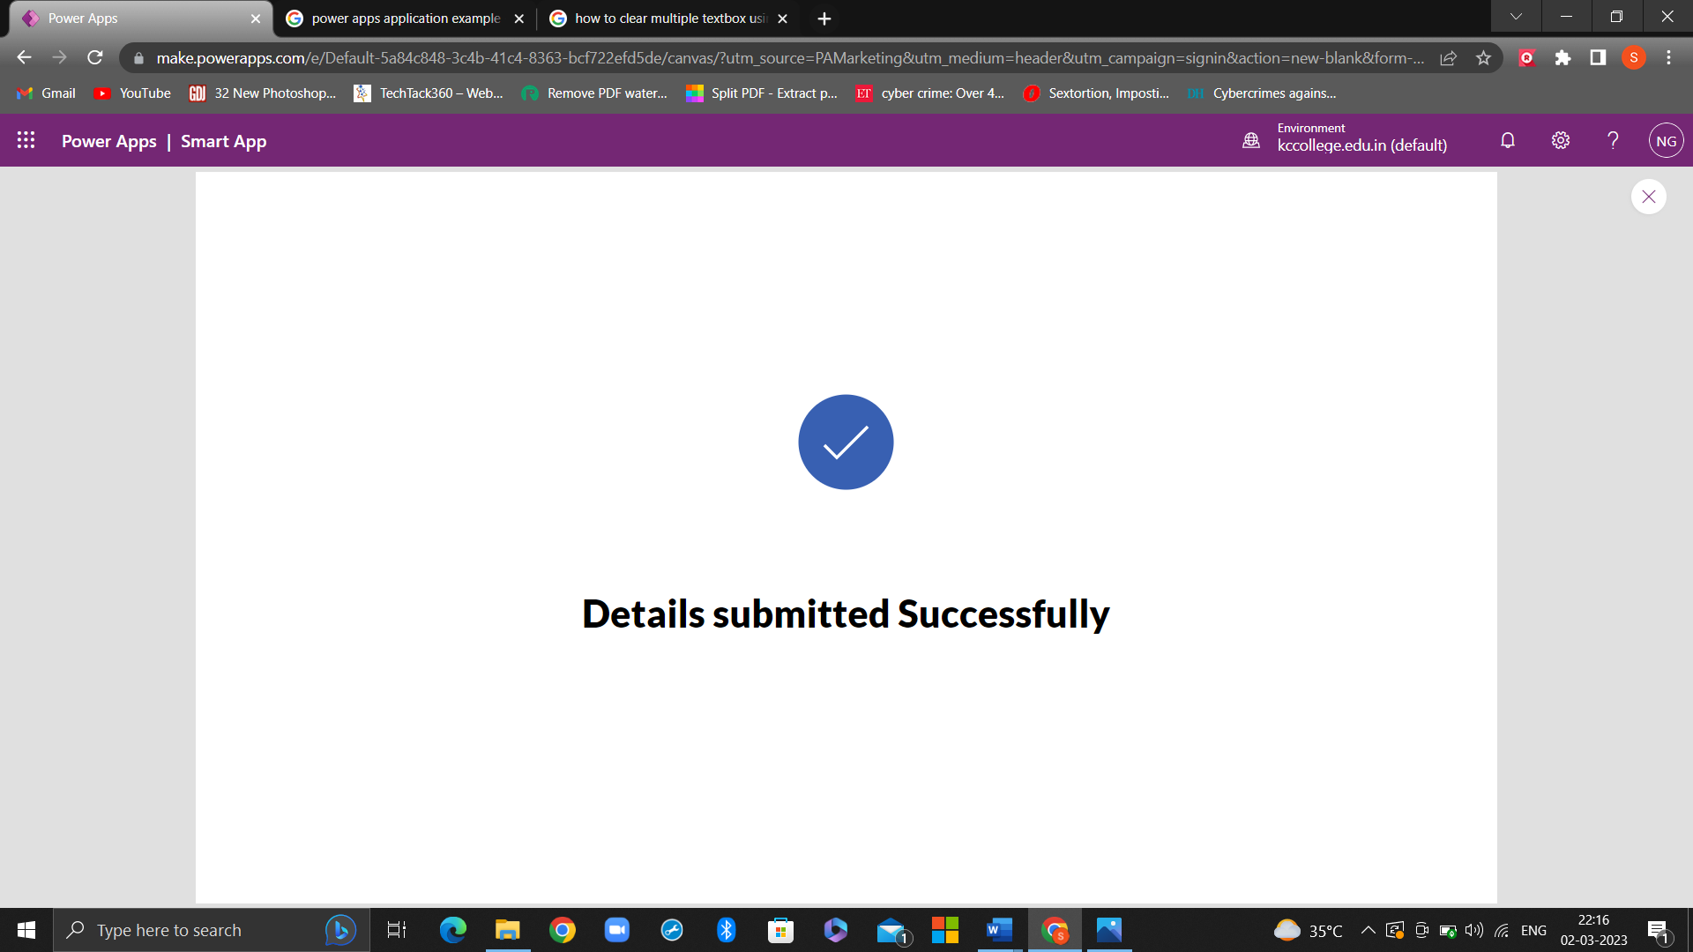

**Practical 3: Using different screens and editing properties**

Step 1: Follow the steps from Practical number 1 to add basic components such as, text label, text inputs, rectangle and button to your app. Click on Insert to add Globe icon

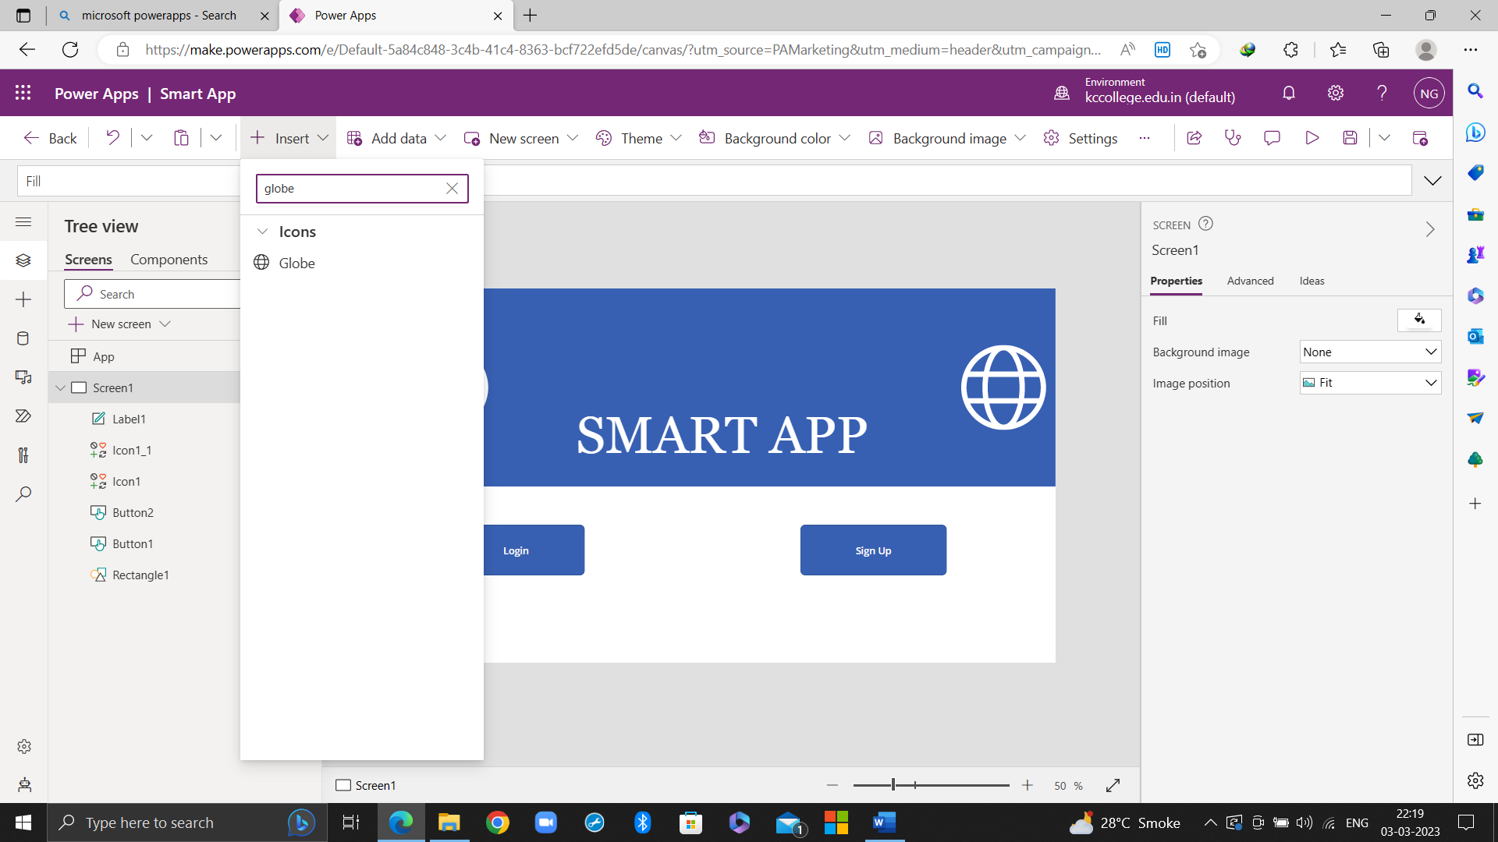

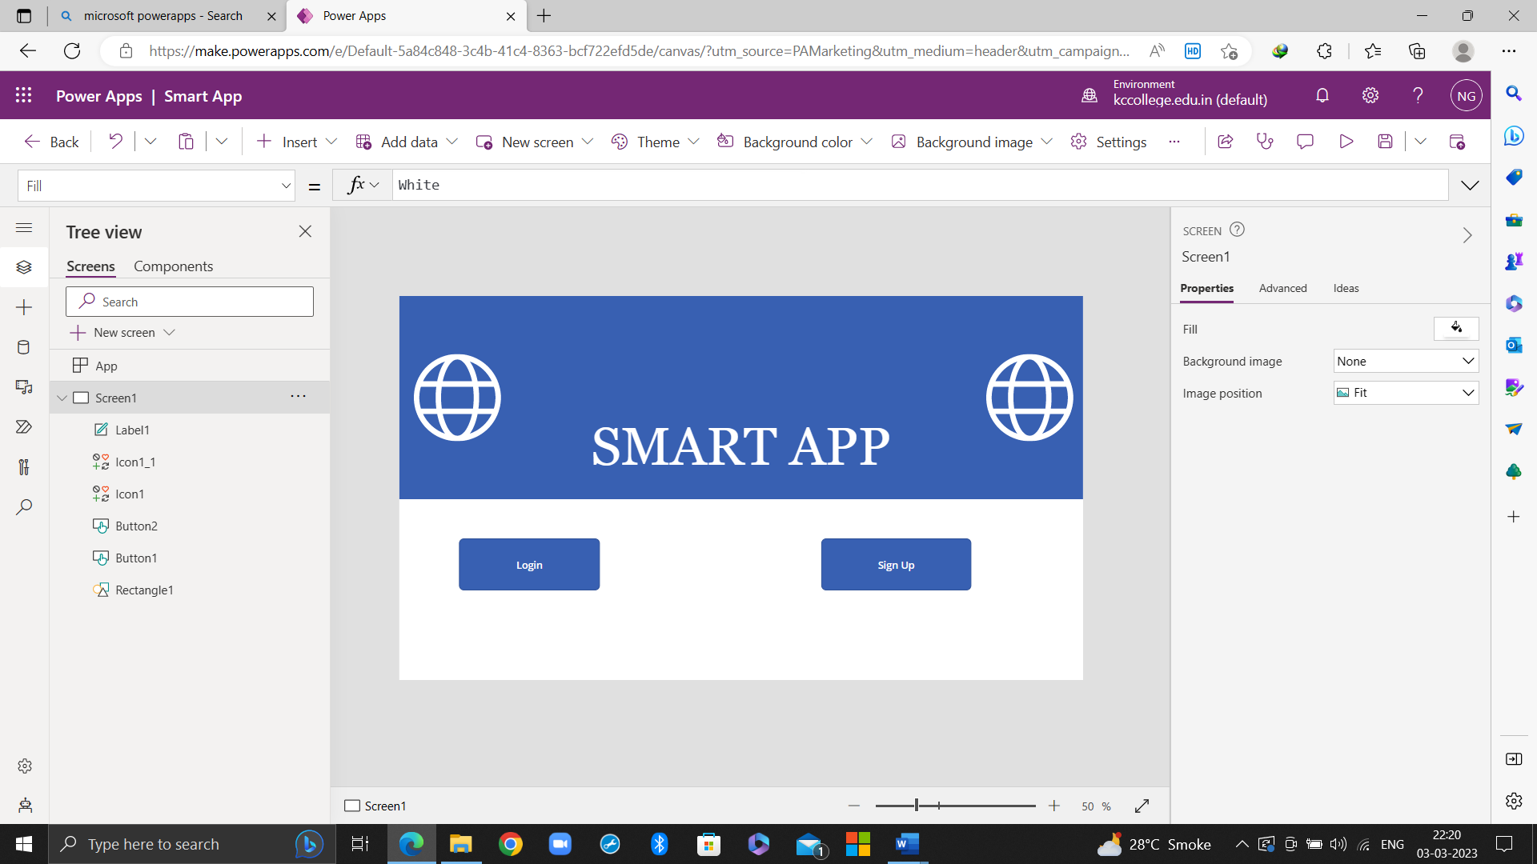

Step 2: To add a new screen, click on the new screen option available below the search button or click on the new screen option available beside the Add data option

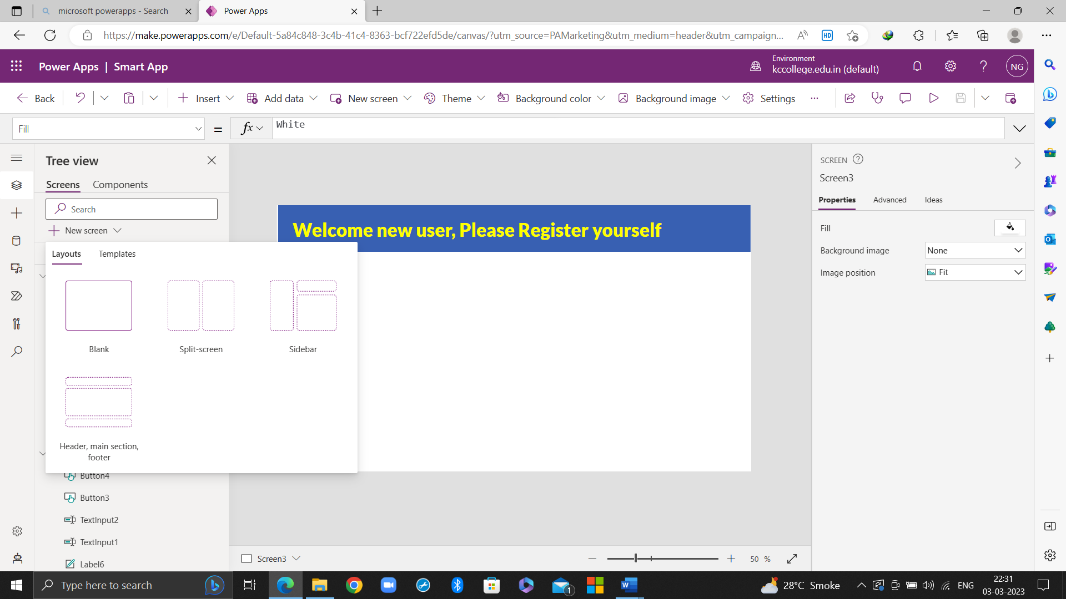

Step 3: In Order to Navigate from screen to screen, use the formula bar and the option of OnSelect. For example: Navigation of Login Button

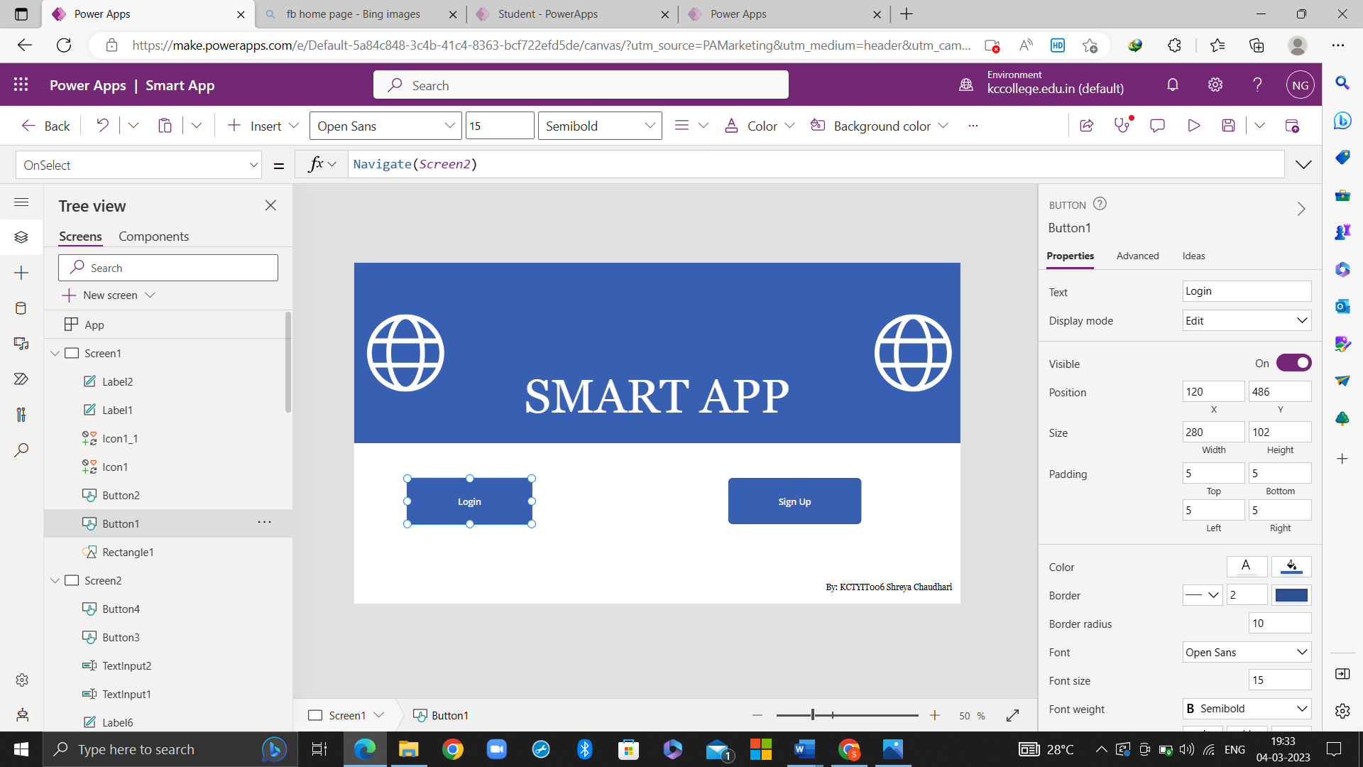

Final app:

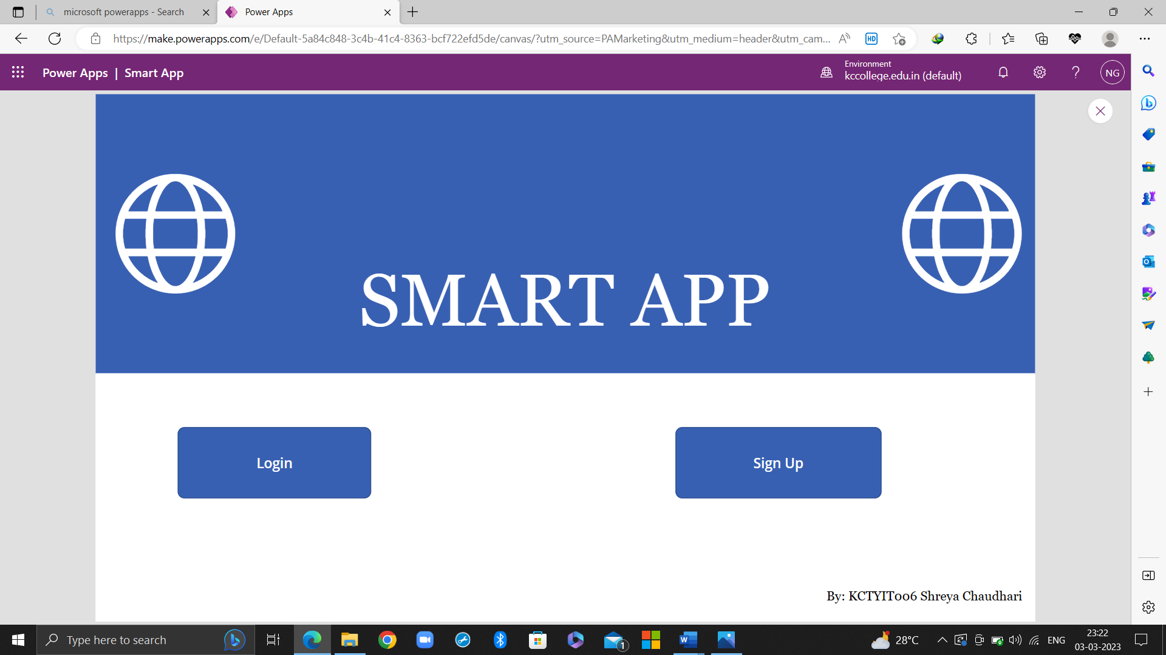

If you click on Login, you will be redirected to:

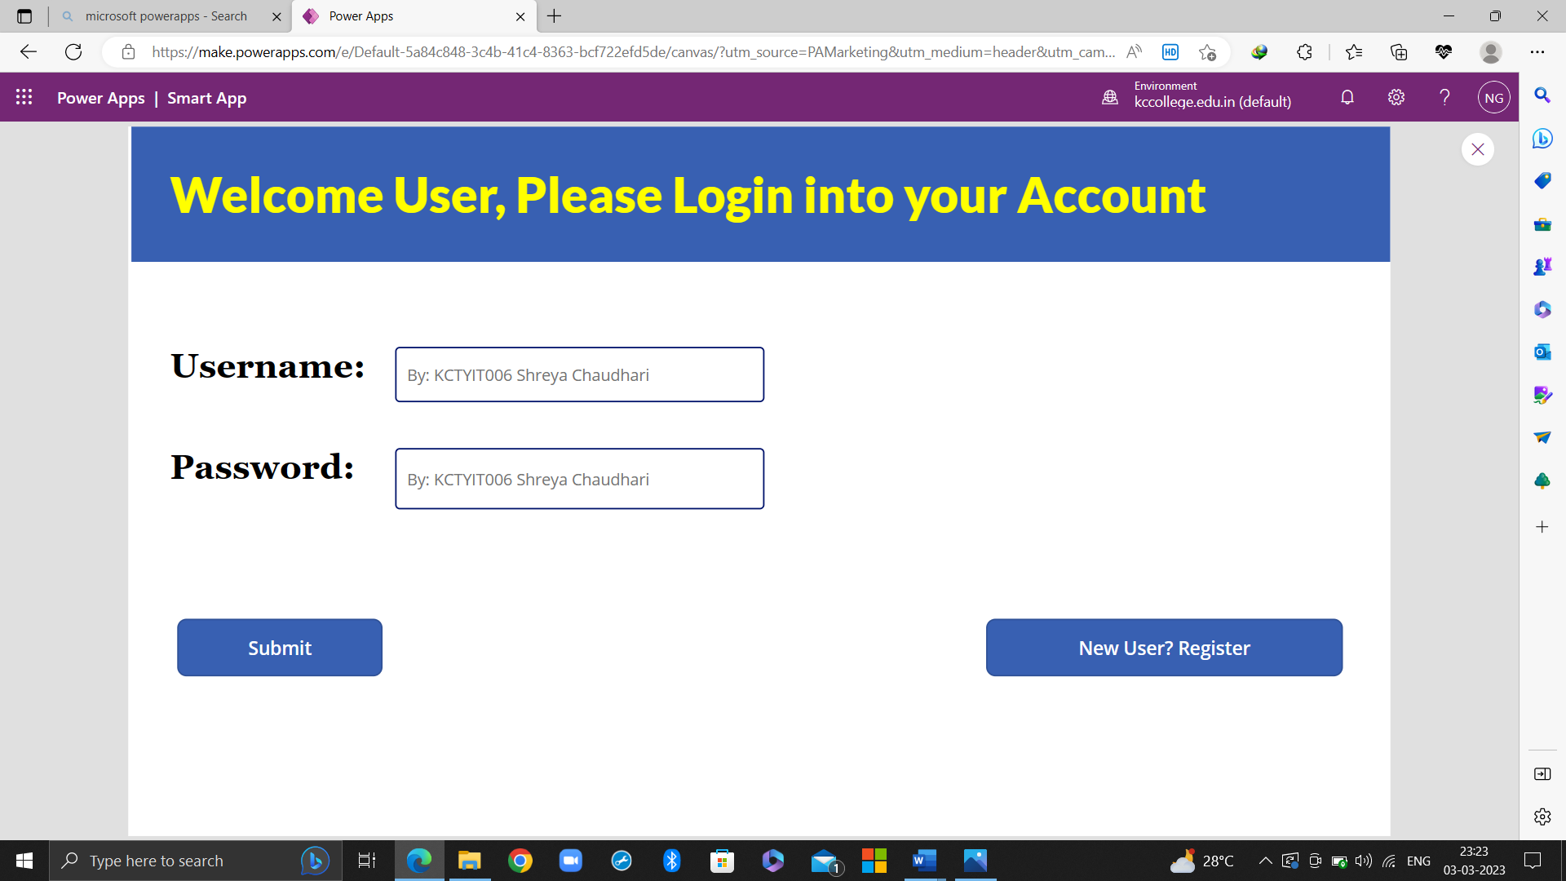

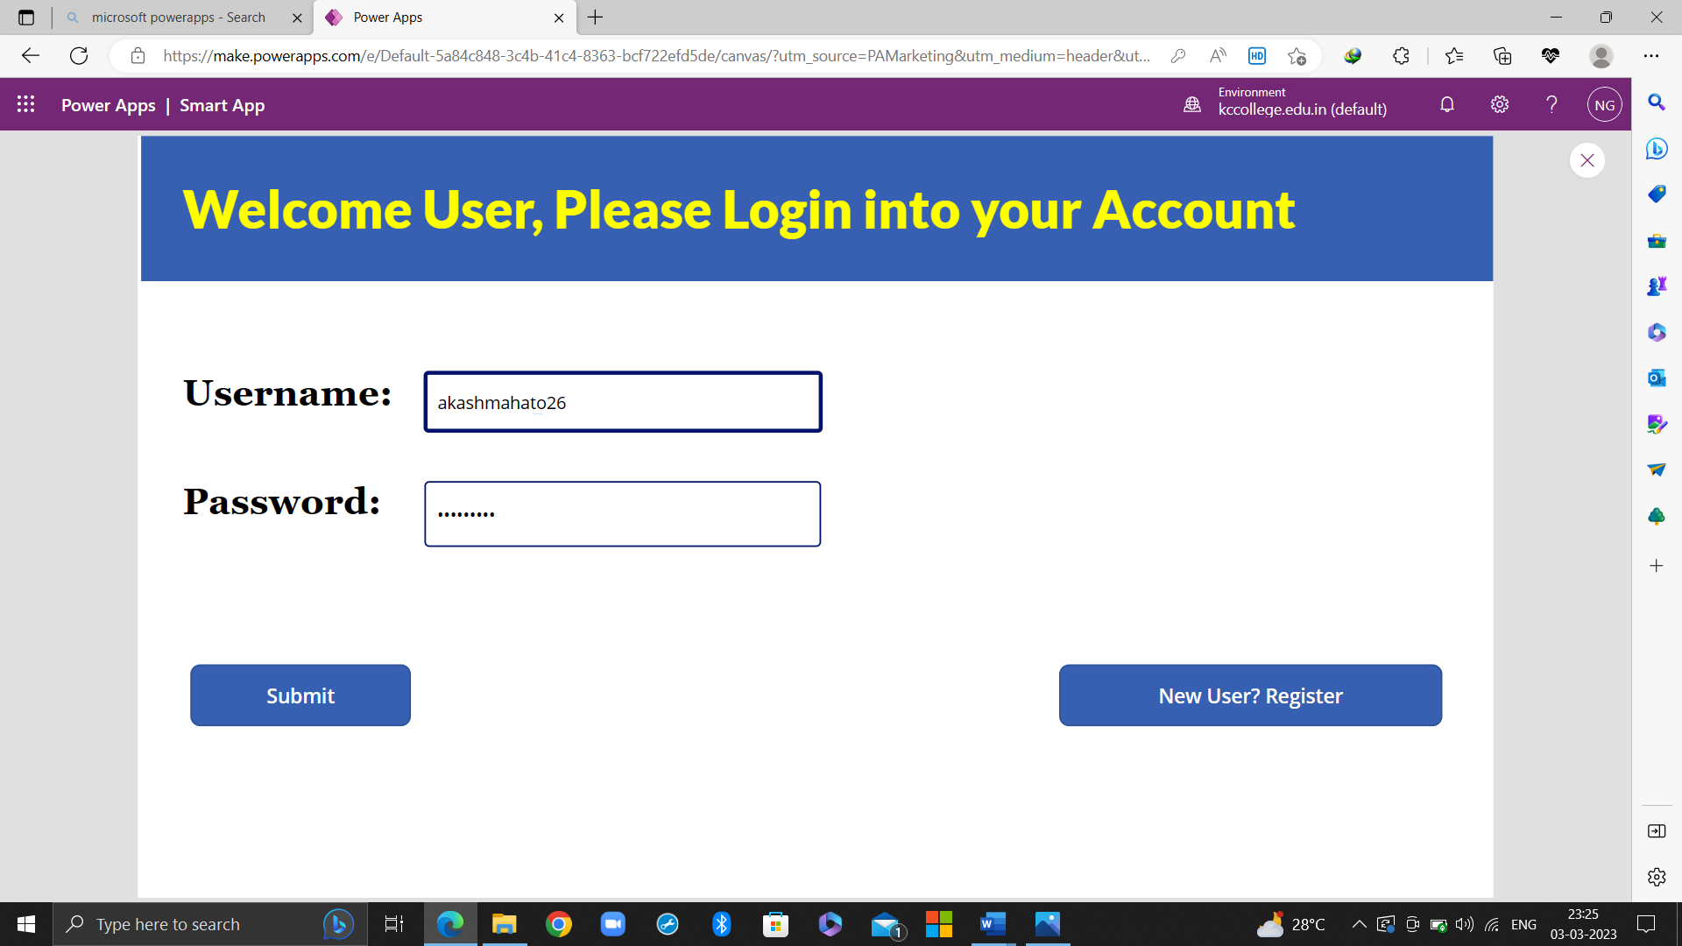

If you click on New User? Register you will be redirected to

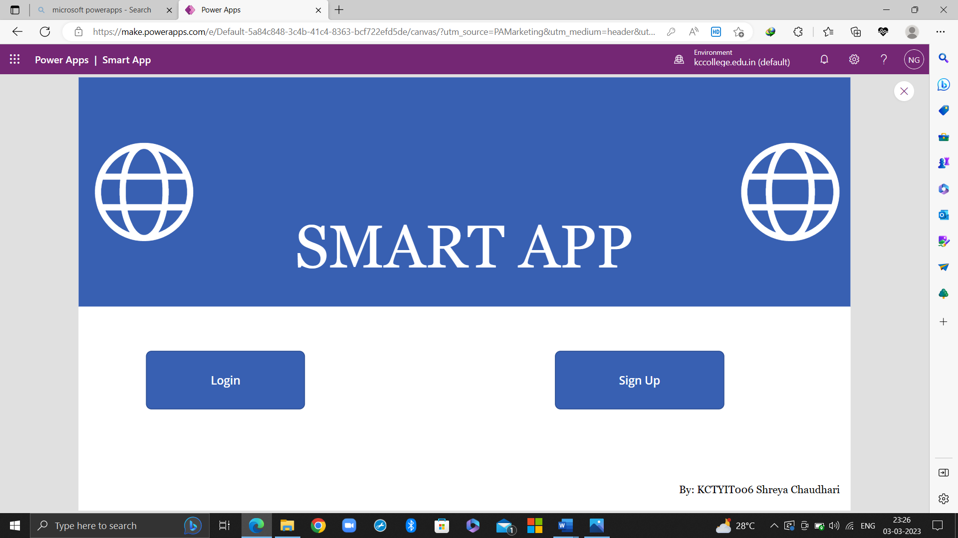

If you click on Sign Up, you will be redirected to

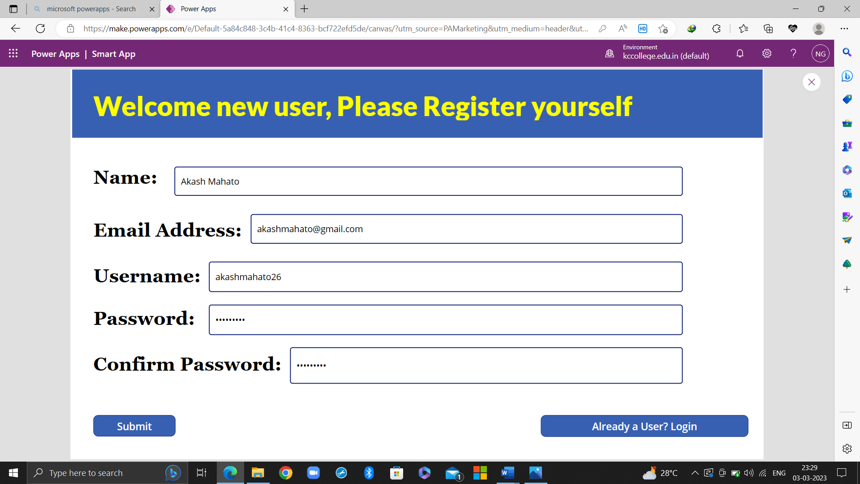

If you click on Already a User? Login, you will be redirected to the main page

After clicking on Submit, you will be redirected to

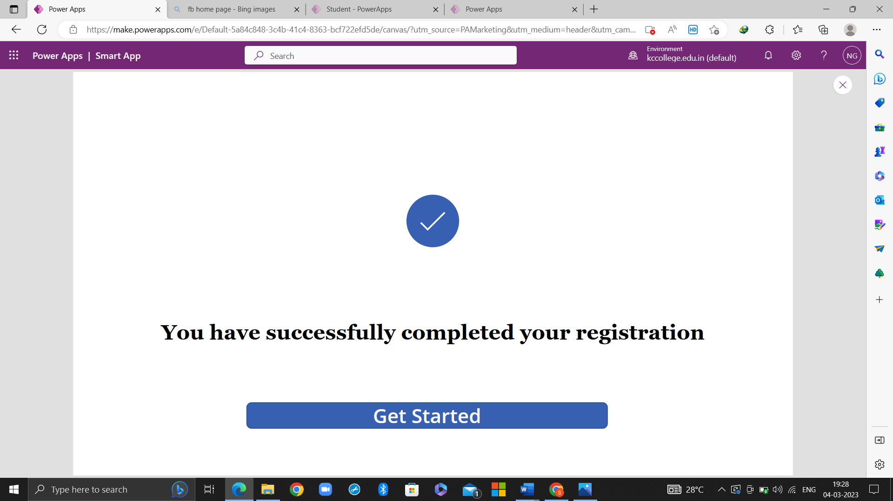

**Practical 4: Using Insert Features such as Forms, Media and Icons etc.**

Step 1: Using steps from Practical number 1 and 3, create a simple application consisting of a login page, registration page and a success page. (Screenshots provided in Practical number 1 and 3)

Step 2: To continue, navigate the Get Started button from the success page to the Home page.



Step 3: To create the Home page, you will need to insert different components such as Image, Add Picture, Rectangle, Text Input, Text Label, Search Icon, Buttons, Microphone.

When you add and arrange all these components on the screen, your home screen will look like this.

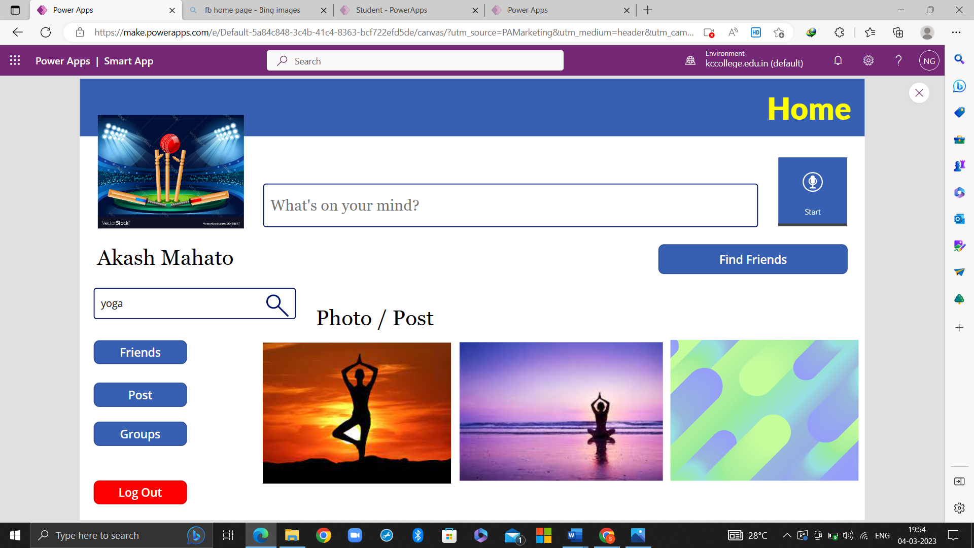

You can be navigated to this screen by two ways, first by clicking on get started after the registration process and second is by clicking submit on the login page

Step 4: When you click on Friends, you will be navigated to a new screen containing a list of your friends.

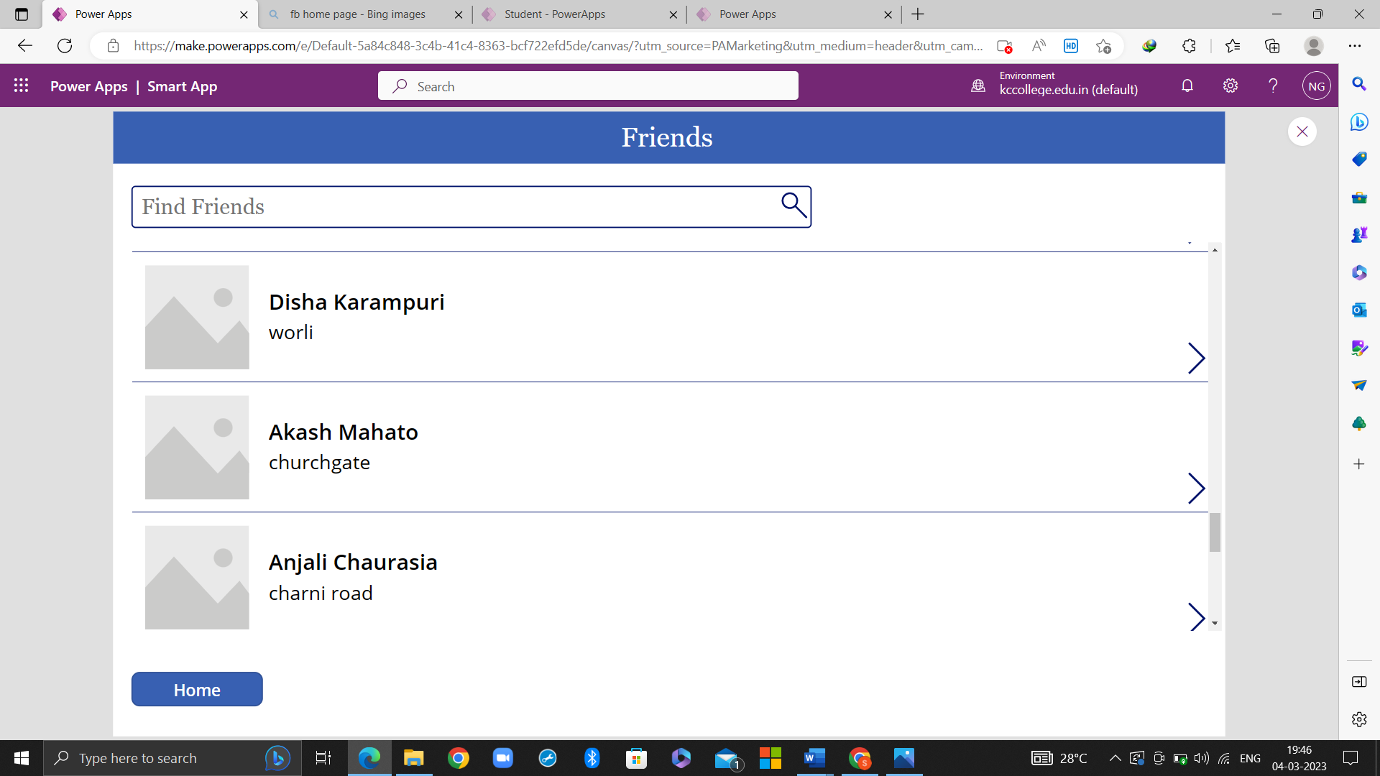

When you click on home, you will be redirected to the home page again.

**Practical 9: Project: Develop an Application of Your Choice**

**(Smart App: Social Media Platform)**

Step 1: To develop this application, you will need to add multiple components such as buttons, text input, text fields, form, gallery, sharepoint, image, microphone, icons, add picture, rectangle.

Step 2: You will also need to use the formula bar for various features such as navigation, filter, etc.

After applying everything, the final application will look like:

Main Page:

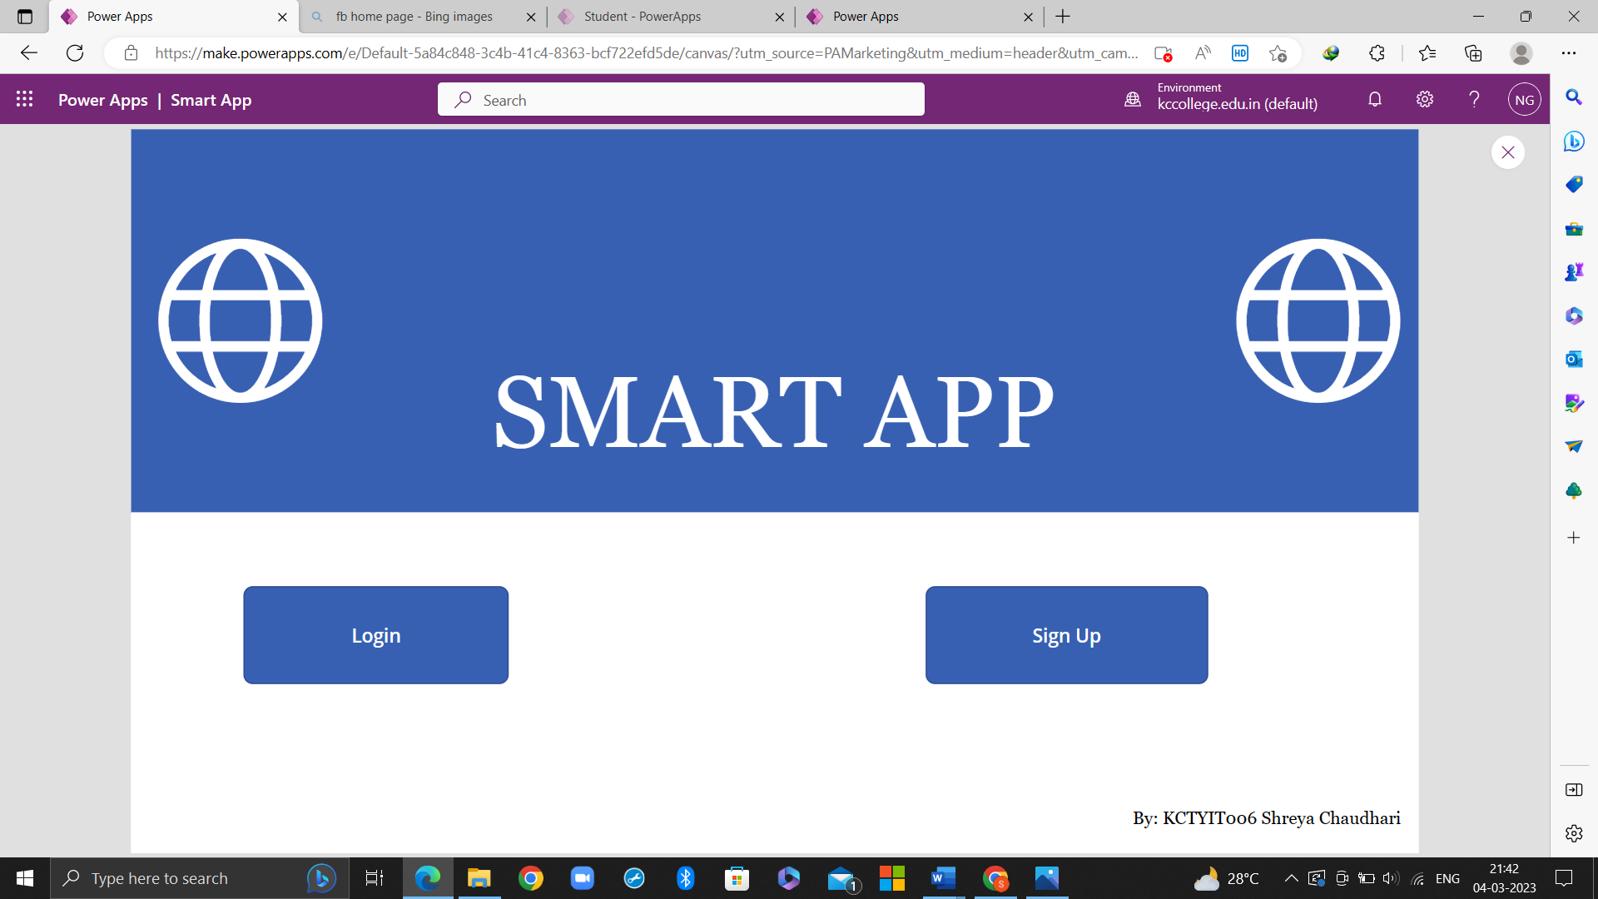

If you press Login:



If you click on Submit, you will be redirected to the Home page:



If you click on New User? Register on the Login Page, you will be redirected to



If you click on Sign Up, you will be redirected to



If you click on Already a User? Login, you will be redirected to the main page

After clicking on Submit, you will be redirected to



When you press on Get Started, you will be redirected to the Home Page:



When you click on Friends, you will be redirected to the Friends page:

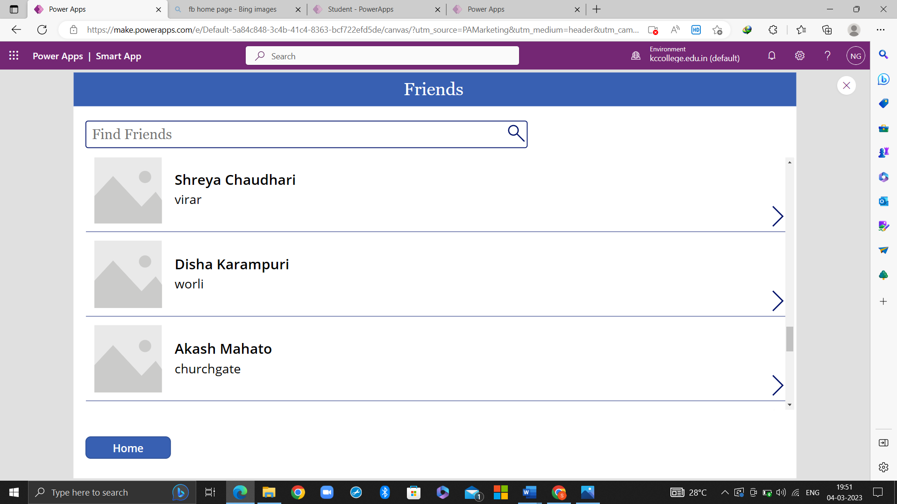

When you click on Home, you will be redirected to the home page again. There you can click the log out button to log out from Smart App.

This screen will appear once you log out from the application:

